Instructions to change your major to one of the three
SCRAPPY (Nursing) Pathways

To change your major to one of three SCRAPPY (Nursing) pathways, follow these simple steps to navigate to the Change Major Portal:
- Login to your Owl Express account
Current Student Information - Kennesaw State University

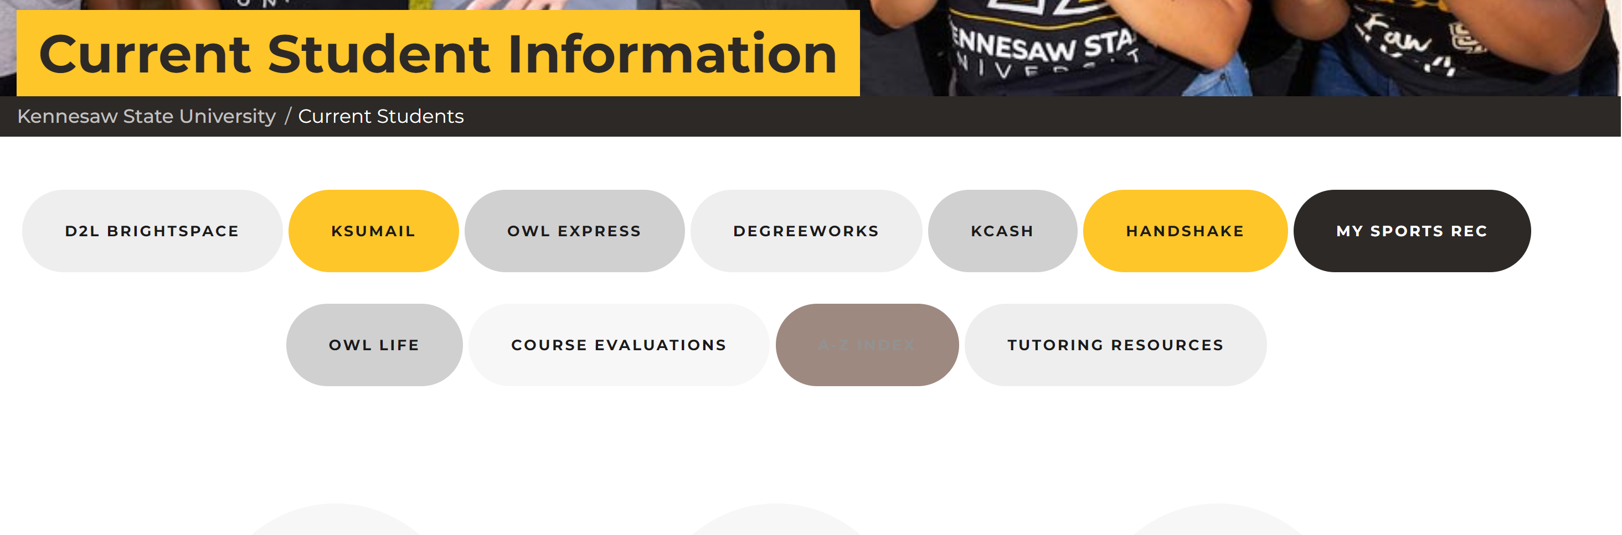
- Click on the Student Records tab
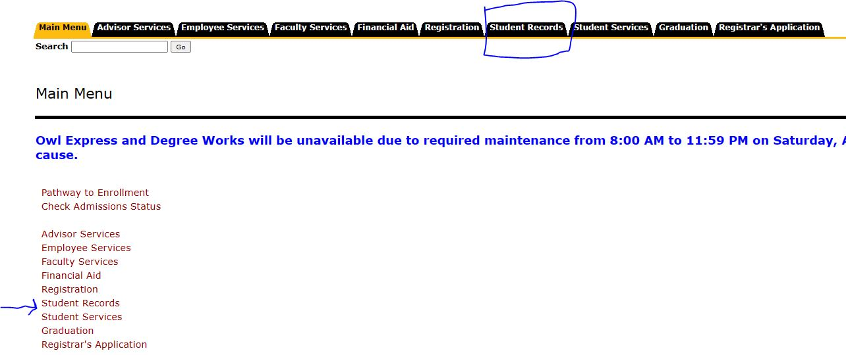
- Click the link “Declare or Change Major/Minor.”
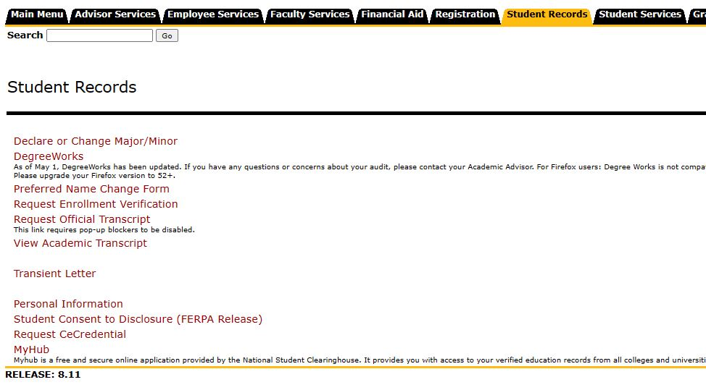
- Click on “change” in the “Primary Program” section to declare your nursing pathway.

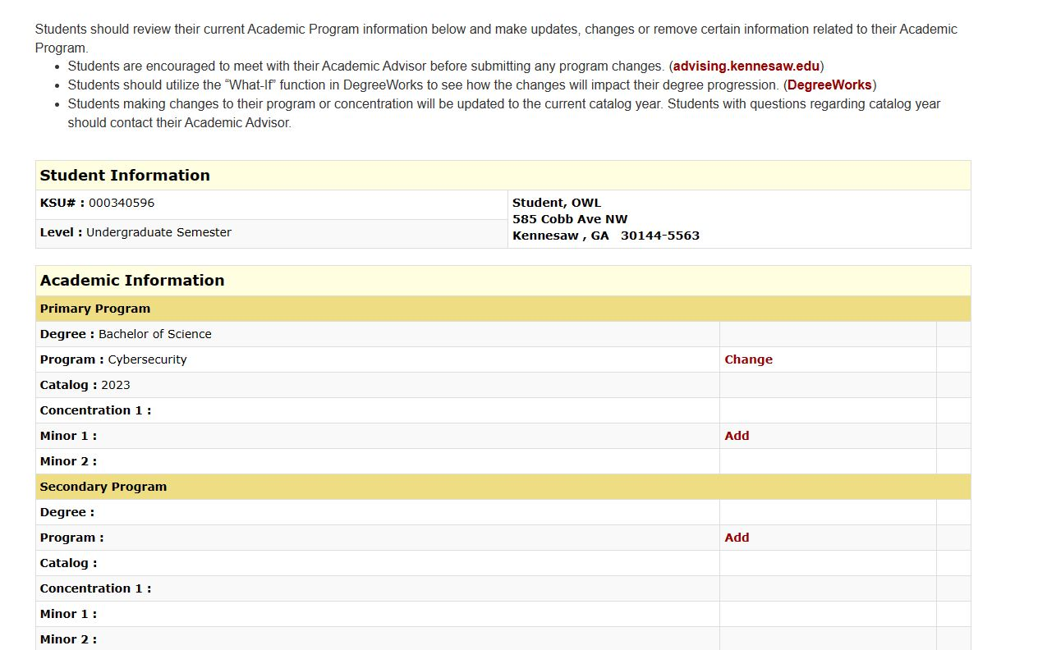
- You will be redirected to the list of available programs. Using the search bar, type in the program you are selecting.
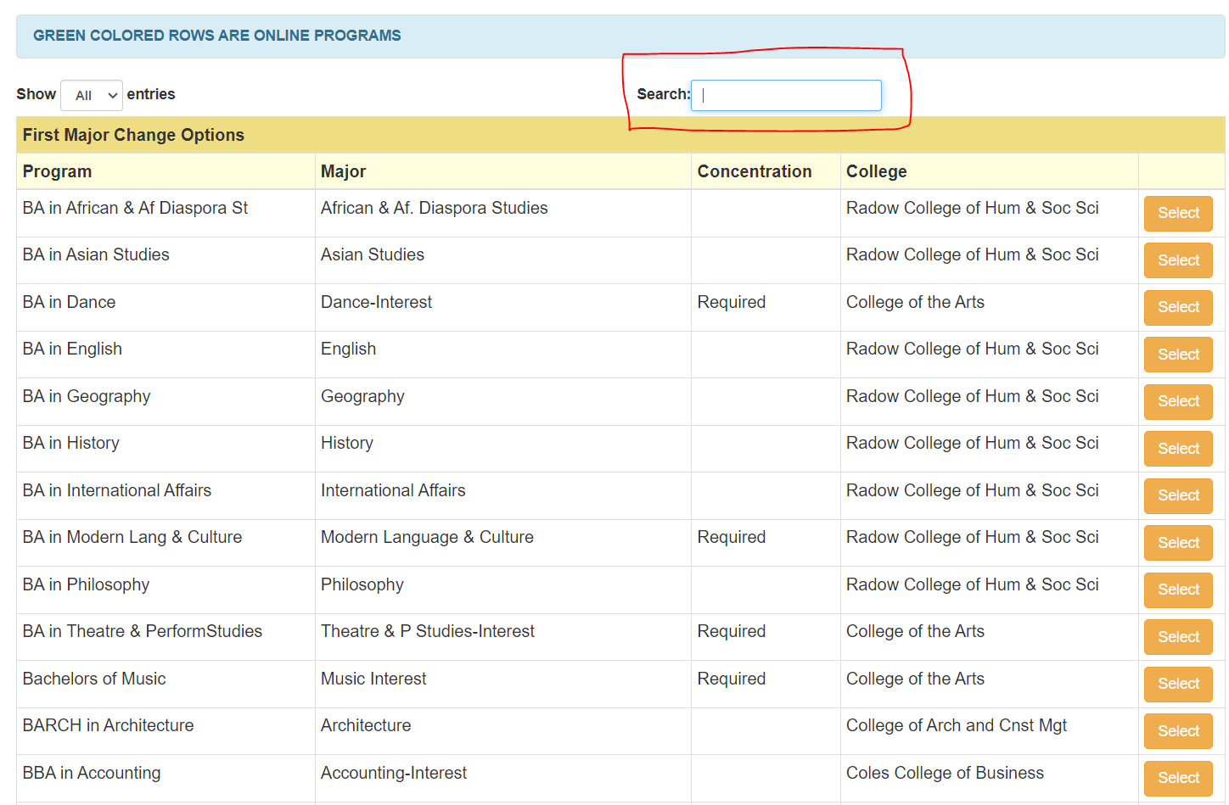
- BS-HS-N with the ZNUI concentration code (Human Services-Nursing Concentration)
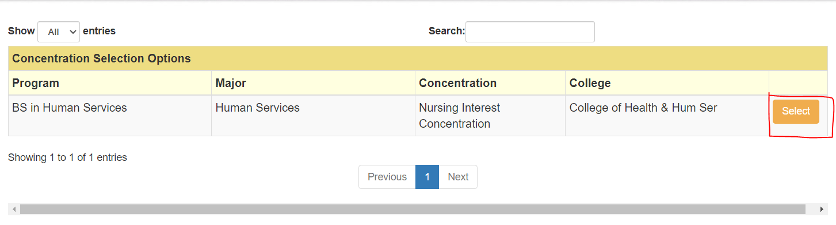
Or
- BS-IHS-N with the ZNUI concentration code (Integrated Health Science-Nursing Concentration)

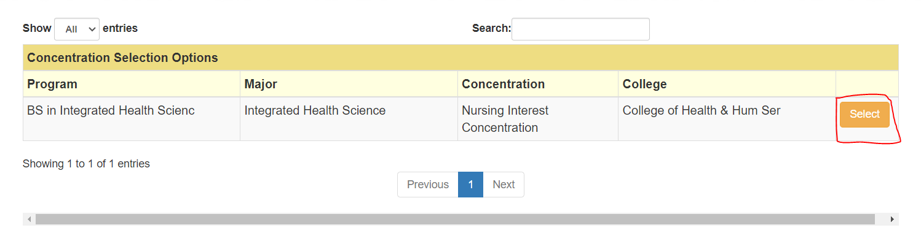
or
- BS-BSPH-N with the ZNUI concentration code (Public Health-Nursing Concentration) *effective in Fall 2024 after August 1.
  - Remember: Public Health with Nursing Concentration – is effective August 1, 2024. Please send an email to WellstarAdvising@kennesaw.edu
- Click “select” beside the new program you are interested in.

- A message will display that your major request is pending. 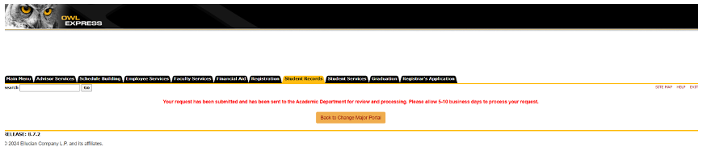

- You can select Back to Change Major Portal, where you can monitor that status at the bottom of the page under “Request Information.”

  - If you decide that was not the major you intended, you can Cancel your pending request in the “Request Information” section. Here you can also see any notes from the academic department if your request was declined.

