Export/Email Catalog Records/Searches

Due to the system migration, your current saved items or searches will be unavailable after June 2025. If you want to keep them, then follow the instructions for exporting, printing, or emailing.

1. Log in to your [Library Account](https://galileo-kennesaw.primo.exlibrisgroup.com/discovery/search?vid=01GALI_KENNESAW:KSU_V1&tab=LibraryCatalog)
2. Go to my favorites (thumbtack image) on the upper right  
   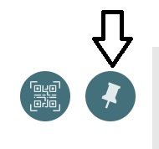
3. Select all your items or individual items that you want to save  
   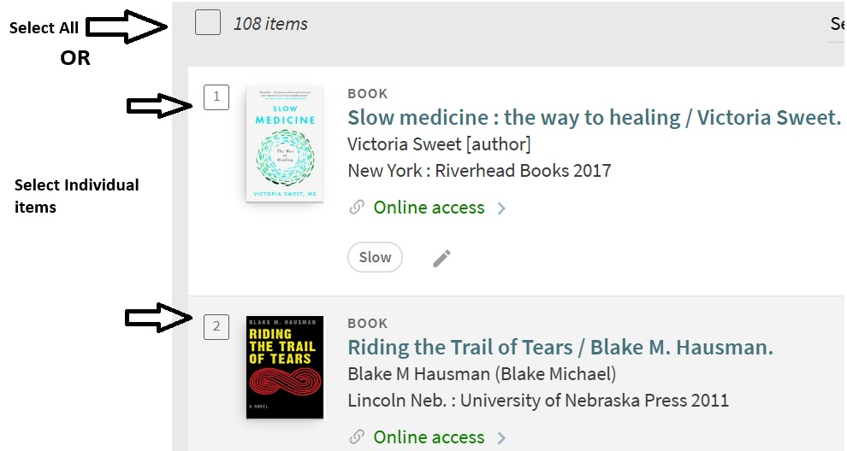
4. Select the ellipsis and choose your method of exporting, printing, or emailing your items  
   