Replace your catalog links with SuperSearch links

After June 2025, the current catalog links will no longer be active. Follow the instructions to replace them with SuperSearch links.

1. Search for the item by title in SuperSearch
2. Select the ellipsis on the right side  
   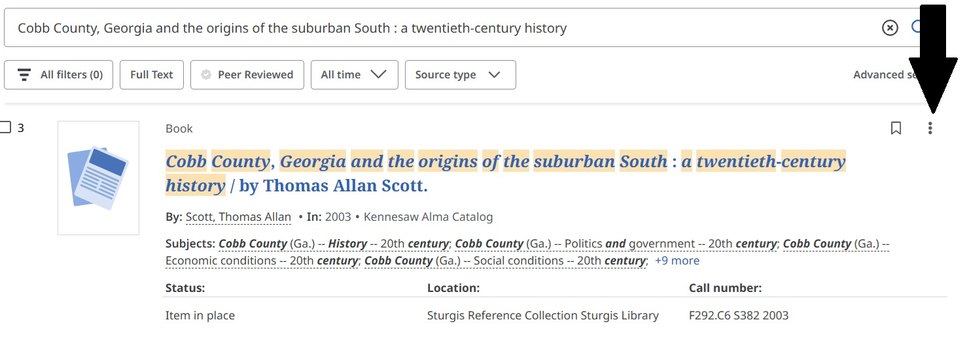
3. Select “Share”  
   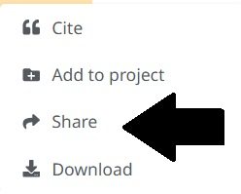
4. Select “Create link” and copy and paste to your desired location  
   