IMPORTANT: PLEASE ACCESS THE uHOO ANALYTICS DASHBOARD ONLY ON KSU DEVICES AND USING A VPN, IF NEEDED.

Accessing the uHoo Analytics Dashboard via Power BI

The uHoo Analytics Dashboard is supported by the Power BI app. You may access the uHoo Analytics Dashboards easily using one of two ways: through MS Teams and through MS Outlook.

Pilot Groups: Please access Power BI through MS Teams at this time.

There may be some variation from what you see on your screen, but the instructions serve as an overall guide.

Accessing Power BI via MS Teams

Step 1: If you don’t have the Desktop App version of MS Teams, download it here.
Step 2: Launch MS Teams app and click the Apps icon at the bottom of the menu on the right. In the Search box at the top, type Power BI and click the Open button to the right of the Power BI result.

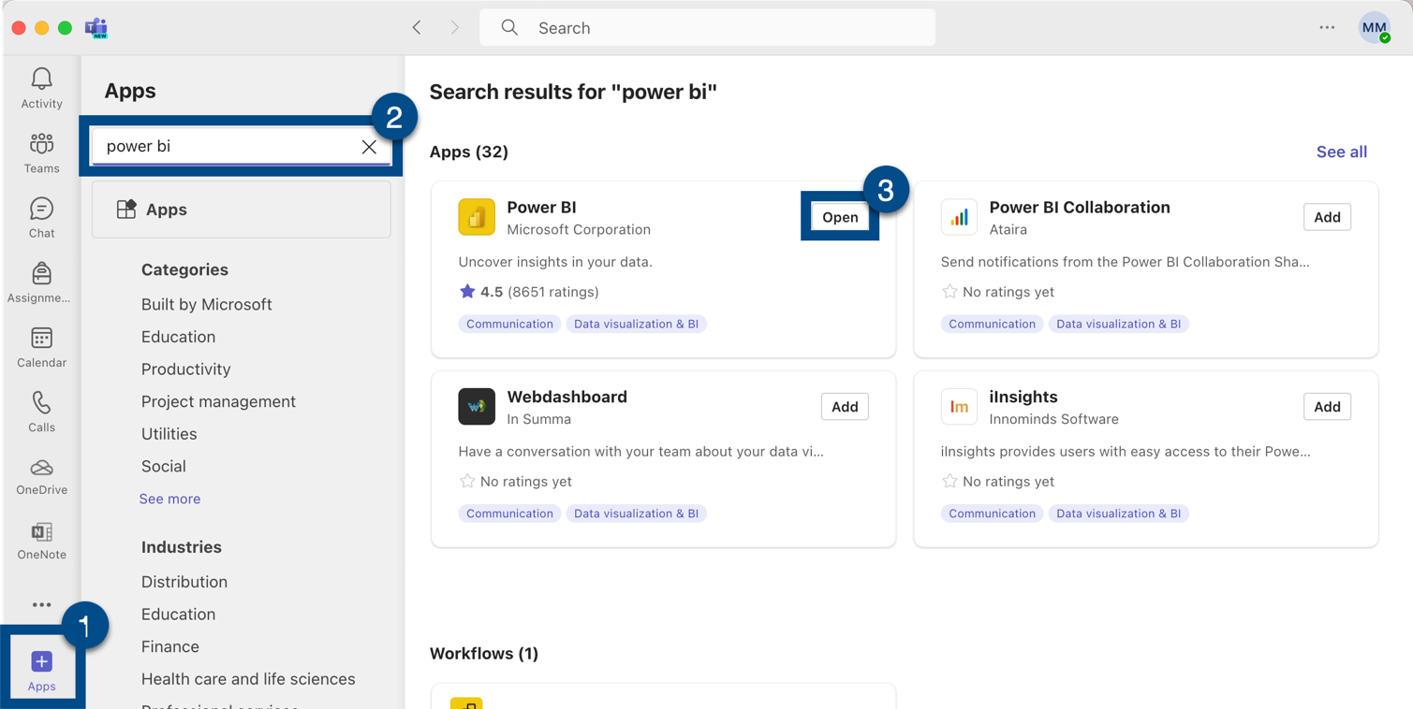
Figure 1 - Screenshot demonstrating launching MS Teams app, searching, and clicking the Power Bi option

Step 3: You may see a pop-up screen. If you do, click the Add button to add the Power BI app to your MS Teams menu.

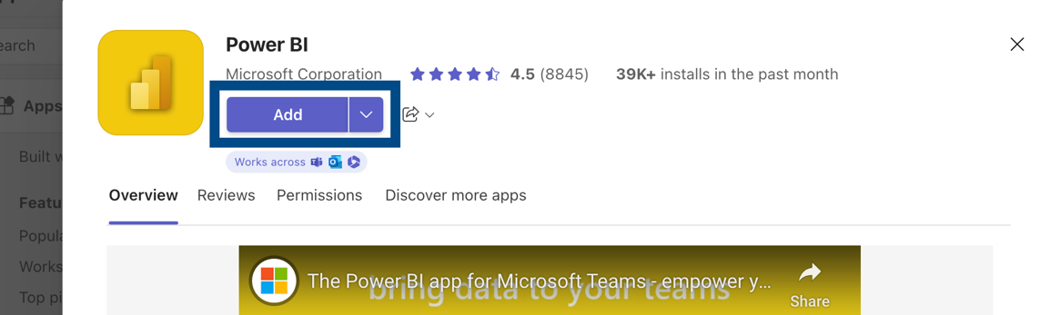
Figure 2 - Screenshot displaying the Add button

Step 4: The Power BI app icon will now display at the bottom of the menu. Right click the icon and select Pin from the Dropdown menu. Pinning the app will make it easier for you to access in the future.

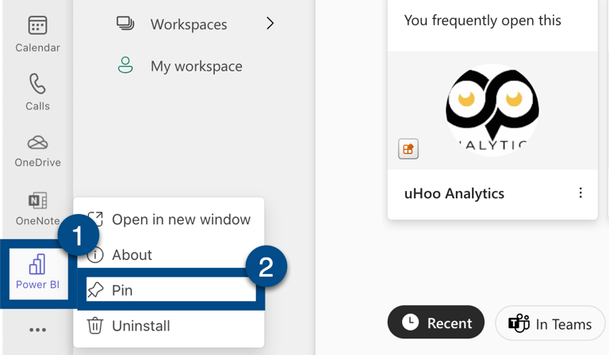
Figure 3 - Screenshot of pinning Power BI icon to Teams menu

Step 5: Click the Apps icon within the Power BI menu to open the apps available to you. If you do not see the option for uHoo Analytics, perform a search for uHoo Analytics in the search bar. Then, click uHoo Analytics.

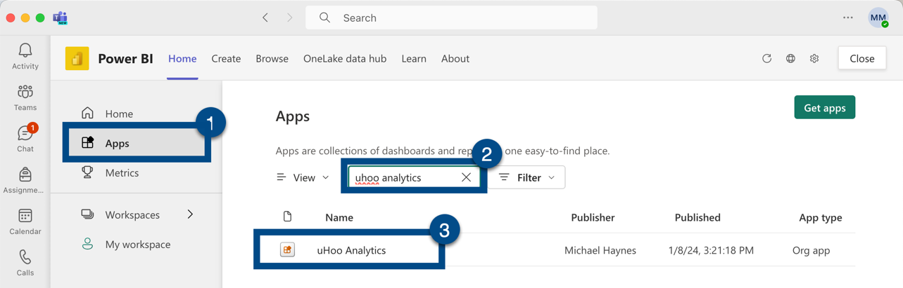
Figure 4 - Screenshot demonstrating searching for and selecting the uHoo Analytics app option
You will now be able to access and use the uHoo Analytics dashboards in your browser.

Accessing Power BI via Outlook

Step 1: Open MS Outlook email in your browser.
Step 2: Click the “waffle” icon (App Launcher).

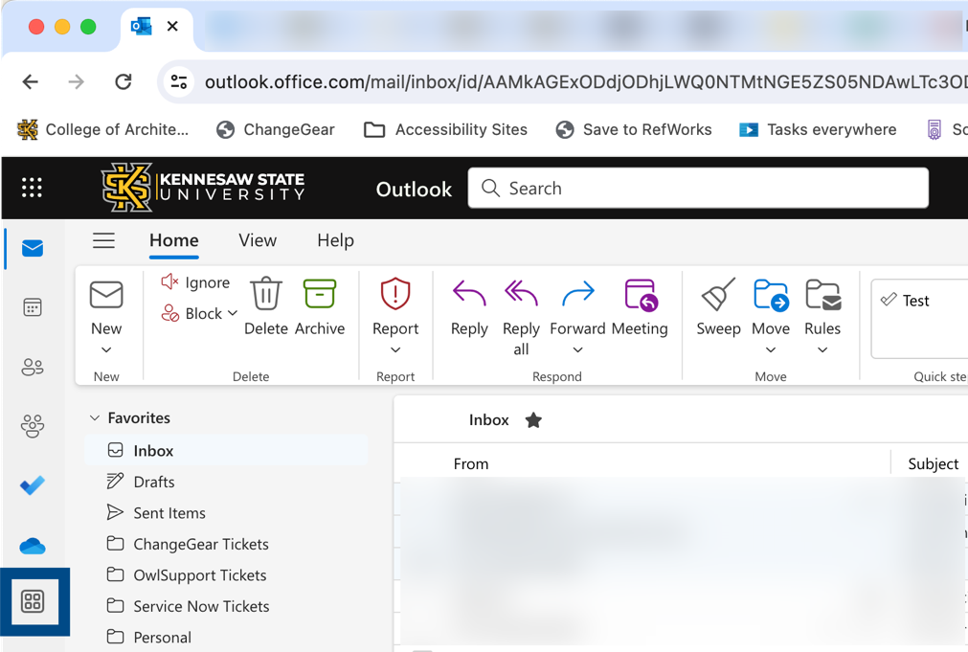
Figure 5 - Screenshot of browser version of MS Outlook waffle icon
Step 3: In the search box that appears, type Power Bi. Then, click the Power Bi app icon.

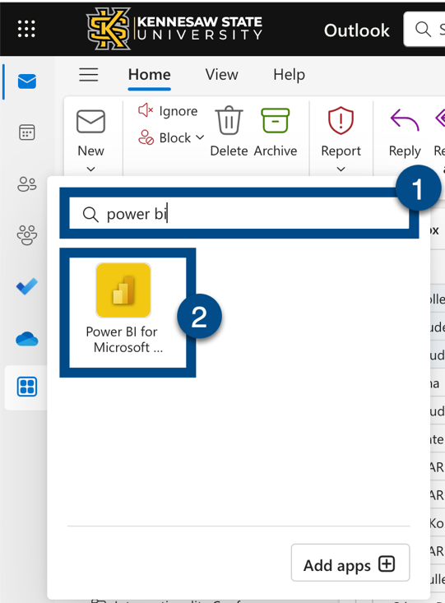
Figure 6 - Screenshot of subsequent dropdown menu with the option to click All apps

Step 4: Right-click the Power bi icon. A sub menu will open; click the Pin option.

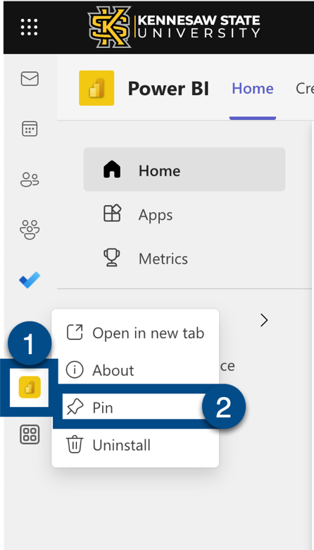
Figure 7 - Screenshot of Power BI selection and pinning

Step 5: Click the Apps icon within the Power BI menu to open the apps available to you. If you do not see the option for uHoo Analytics, perform a search for uHoo Analytics in the search bar. Then, click uHoo Analytics.

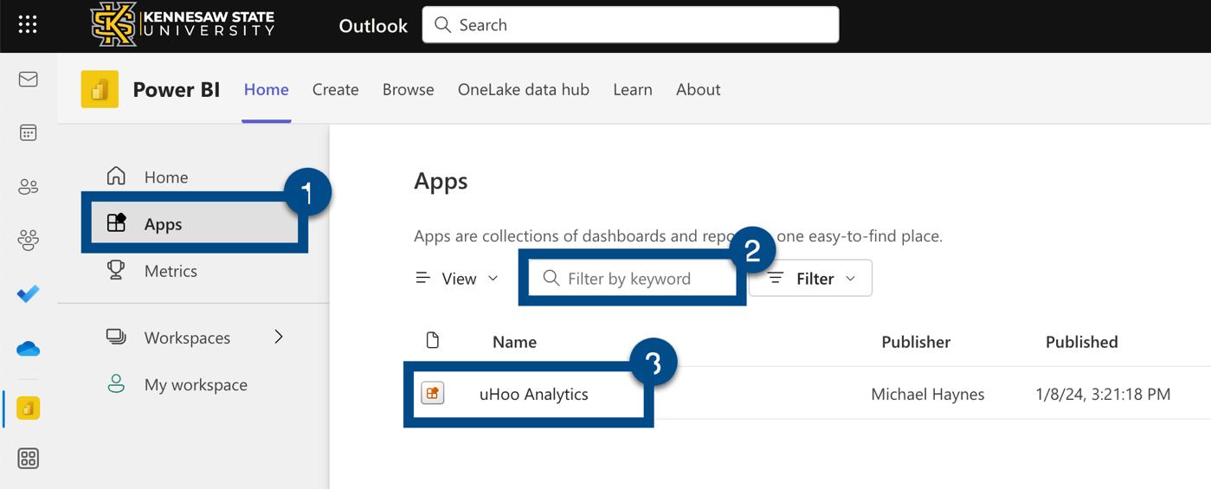
Figure 8 - Screenshot of Power BI icon pinned in the waffle menu

You will now be able to access and use the uHoo Analytics dashboards in your browser.

Subsequent Access the uHoo Analytics Dashboard via Power BI

MS Teams:
Once you have followed the instructions above to download MS Teams, pin the Power BI app, and access your dashboard, you can return to your dashboard anytime by

- Launching the MS Teams app.
- Clicking the Power BI icon in the menu on the right.
- Clicking the Power BI Apps menu and then the STUDENT SUCCESS App as shown in Step 5 above.

MS Outlook
Once you have followed the instructions above to pin the Power BI app on the Outlook menu and access your dashboard, you can return to your dashboard anytime by

- Launching MS Outlook.
- Clicking the App launcher (waffle) icon and then clicking on the Power BI icon in the menu.
- Clicking the Power BI Apps menu and then the STUDENT SUCCESS App as shown in Step 5 above.

