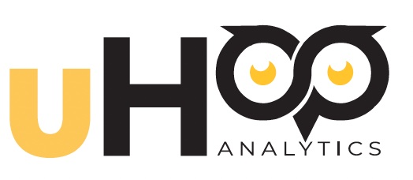

uHoo Analytics

Job Aid

Spring 2024

Table of Contents
Table of Contents 2
Learning Outcomes 4
Key Benefits 4
Introduction 4
What is learning science? 4
What is learning analytics? 4
How can learning analytics be used to support student success? 5
What kinds of data are collected in learning analytics? 5
How is student data used in learning analytics? 5
How can instructors use learning analytics to improve their teaching? 5
What kind of data will I have access to in the uHoo dashboard? 5
Where does this data come from? 5
Who can access the data from my courses? 5
Is this for online courses only? 6
Overview of the uHoo Analytics Dashboards 6
Interacting with the Data 7
Dashboard Navigation Basics 9
Course Analysis Dashboard 9
Filters 9
Visualizations 10
Assignment/Quiz Analysis Dashboard 11
Filters 11
Visualizations 11
Student Analysis Dashboard 12
Filters 12
Visualizations 12
Quiz Analysis Dashboard 13
Filters 13
Visualizations 13
Alert Analysis Dashboard 15
Filters 15
Visualizations 15
Best Practices in D2L for Instructors 16
Assignments 16
Quizzes 16
Content 16
Grades 17
Attendance 17
Need Help? 17
Tips for Responding to Dashboard Alerts 18
Documenting your Impact on Student Success 18
Learning Analytics for SoTL Research 19
Ethics and Learning Analytics 19
1. Privacy 20
2. Data Accuracy and Interpretation 20
3. Equity and Fairness 20
4. Ethical Use of Results 20
5. Professional Responsibility 20
Additional Resources 21

Learning Outcomes
Upon completion of this training, you will be able to
- Access the uHoo Analytics dashboards.
- Interact with the visualizations on the dashboards to display data trends for the entire class and individual students on assignments, quizzes, attendance, and engagement with the course.
- Apply skills as a researcher/learning scientist to the data to identify opportunities for supporting individual students and to inform instructional decisions.

Key Benefits
- Improve your data-driven decision-making.
- Identify and act on opportunities for early intervention and support.
- Customize learning experiences to meet student needs.
- Get real-time feedback on student learning and instructional strategies.
- Improve communications and engagement with students.

Introduction
uHoo Analytics is a learning analytics platform that collects and organizes data from D2L courses in Banner so that instructors can use their research skills – becoming learning scientists – to analyze and respond to student learning needs, thereby supporting student success. The data is presented in a series of dashboards with filters that instructors can manipulate to view records of class and individual student progress and success.
Every Monday, instructors will receive an email called Monday Measures from uHoo Analytics. This email will summarize alerts to potential concerns about student performance and engagement. Clicking the links within the Monday Measures email will open the uHoo Analytics dashboards.

What is learning science?
Learning science applies research practices to identify ways in which instructors can improve their teaching and support student success. Learning science draws from many disciplines, including cognitive science, educational psychology, instructional design, data science, and learning analytics.

What is learning analytics?
Learning analytics is the use of data to inform and improve teaching and learning. It involves applying research skills such as collecting and analyzing data on student performance, engagement, and behavior to identify patterns and trends and make informed decisions about how to support student success.

How can learning analytics be used to support student success?
Learning analytics can be used in many ways to support student success, such as identifying at-risk students, providing personalized feedback and support, and improving course design and delivery.

What kinds of data are collected in learning analytics?
Learning analytics can involve the collection and analysis of a range of data, including student demographics, course grades, engagement with course materials, and participation in online discussions and activities.

How is student data used in learning analytics?
Student data is used in learning analytics to inform decision-making related to teaching and learning. This can include identifying areas where students may need additional support, developing personalized learning plans, and improving course design and delivery.

How can instructors use learning analytics to improve their teaching?
Faculty can use learning analytics to inform their teaching by identifying areas where students may be struggling or disengaged and adjusting their teaching strategies accordingly. For example, faculty may use learning analytics to identify which course materials are most effective or to provide personalized feedback to students.

What kind of data will I have access to in the uHoo dashboard?
The analytics dashboard will provide data about classes (overall student performance, attendance, logins, and engagement with topics/modules), individual students (performance, attendance, logins, and engagement with topics/modules, comparisons to class data), and assignments and quizzes (overall class performance, performance by question).

Where does this data come from?
All the data is already collected in D2L. The uHoo analytics dashboards make it easily accessible to you.

Who can access the data from my courses?
Only you! Initially, no one else will have access to your data and dashboard except for you. If you want to provide someone with access, you must add their name to the D2L section as an instructor, secondary instructor, non-edit instructor, or non-grading instructor.

Is this for online courses only?
No! Instructors of face-to-face courses who use D2L, even if only to record grades, will benefit from using this data.

Overview of the uHoo Analytics Dashboards
uHoo Analytics displays data from many components of D2L: Login engagement with content (modules/units, discussion boards, etc.), quiz scores, assignment scores, current cumulative grades, and attendance. The more data you create in D2L, by tracking students’ grades on assignments and quizzes, and keeping attendance records, the more data will populate in these dashboards. For example, if attendance is not recorded in D2L, there will be no data displayed in the uHoo Analytics Dashboard.
uHoo Analytics is comprised of the following dashboards:
- Course Analysis – Displays data and alerts for all students in a selected course.
- Assignment/Quiz Analysis – Displays data for quizzes, assignments, and rubrics for the selected course.
- Student Analysis – Displays data for individual students in the course.
- Quiz Question Analysis – Displays data for individual quiz questions in a selected quiz in the selected course.
- Alert Analysis – Displays data for assignment, quiz, and engagement alerts.
- Rubric Analysis (Coming Soon!) - Displays data for individual rubric criteria in a selected rubric in the selected course.

Interacting with the Data
You can interact with the data, copy it, and get more information in several ways.
The tabs in the top-right corner of most visualizations provide additional options for interacting with the data, outlined below.
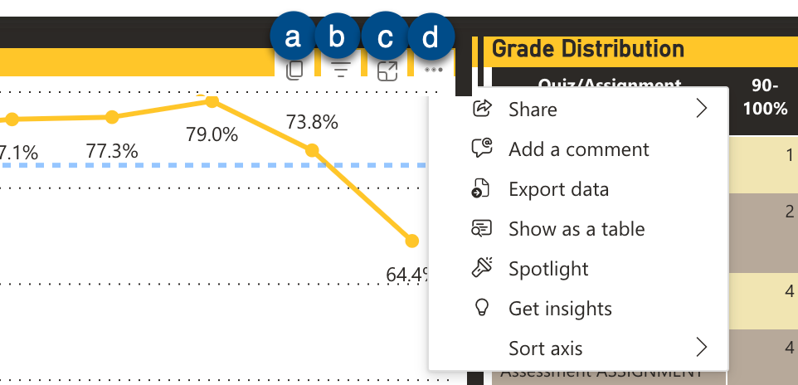
Figure 1 - Screenshot of tabs in the top-right corner of each data visualization
- Copy – Click this icon to copy the entire visualization with the caption.
- Filters and Slicers – Click this icon to see which data points are active in the visualization.
- Focus – Click to enlarge the chart or table.
- Ellipse – Click the ellipses icon opens options such as sharing, adding a comment, exporting data, showing data in a table (as applicable), spotlighting the visualization (which dims the other visualizations on the dashboard), getting insights (which is not applicable currently), and sorting the data.

NOTE: All the visualizations on the dashboard contain these same tabs at the top.

Drill Down
Right-clicking a selected point on some line graphs and in tables triggers a pop-up menu with options to copy, share, show as a table, (include/exclude), and Drill down. The Drill down table displays students who received an alert due to a score of 60% or below on a quiz or assignment.
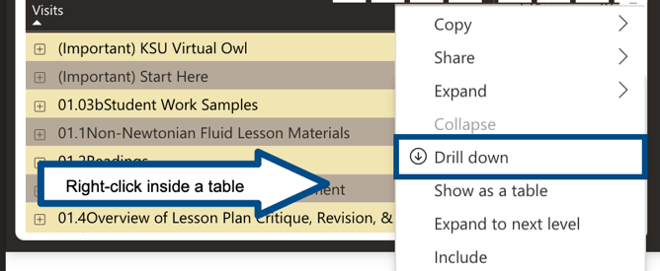
Figure 3 - Right click inside a table to open additional menu with option to Drill Through

Clear Selection
If you have selected an item in a visualization, you may click on it again to unselect it. Also, right clicking inside a visualization brings up a pop-up menu with a choice to Clear selections.
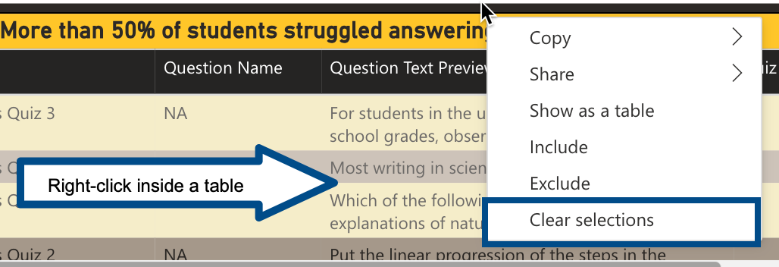
Figure 4 - Right click inside a table to open additional menu and clear selections

Dashboard Navigation Basics
uHoo Analytics is still undergoing some developmental changes. Therefore, the dashboards may contain different visualizations and/or filters than those described in this document. However, navigating among the dashboards and interacting with the visualizations should be consistent throughout the developmental changes.
IMPORTANT: PLEASE ACCESS THE uHOO ANALYTICS DASHBOARD ONLY ON KSU DEVICES AND USING A VPN, IF NEEDED.

Course Analysis Dashboard
The Course Analysis Dashboard displays data for all students in a selected course.

Filters
It is recommended that you make selections (or verify existing selections) in the filters each time you access the data to ensure that you are viewing precisely the selections you want to see. Using these filters is optional, but not selecting an option will leave the default option selected; most of the time, the default will be All.

Note: You can select multiple options in each of these filters by holding down either the Command key on a Mac or the Control key on a PC.

- Semester – Click inside this box and select a semester.
- Course Offering – Click inside this box and select a specific course.
- Grade Book (Item) – Click inside this box and select a specific grade item in the gradebook.
- Grade Book Level – Click inside this box and select a grade value to view, e.g., all scores below 60. Filters class data on all assignments, or on a selected assignment, by grade level.

Clicking the eraser in the top right corner of each dropdown menu will clear all settings. If you have selected a specific course or courses, only the semesters during which that specific course is offered will be displayed in the Semester dropdown menu. You must clear the Course Offering dropdown menu to have access to other semesters.

Visualizations
- Course Final Grade – Displays the average final calculated grade for the class.
- Grade Book Item – Displays class average score by grade book item.
- Grade Distribution – Displays grade levels and totals by assignment/quiz.
- Quiz Alerts – Lists alerts for students who have scored 60% or below on a quiz.
- Assignment Alerts – Lists alerts for students who have scored 60% or below on an assignment.
- Submodule and Topic Visits – Displays percent of students who accessed materials.
- Attendance – Displays percentage of students present by week of the semester. (If you do not keep attendance in D2L, this area will be blank.)

The Course Analysis Dashboard

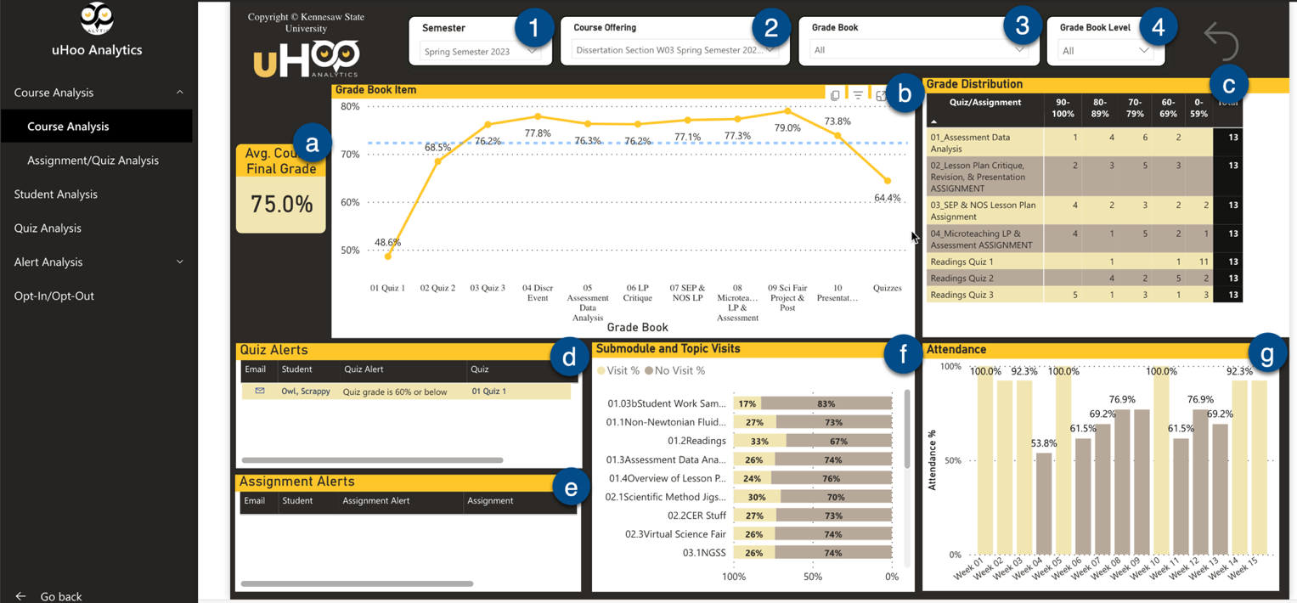
Figure 5 - Screenshot of Course Analysis Dashboard

IMPORTANT NOTE: To display data chronologically on the dashboards, assignments, quizzes, and modules in D2L must be numbered:
- Assignments: 01 Assignment Name, 02 Assignment Name, 03 Assignment Name, etc.
- Modules: Module 01, Module 02, Module 03, etc.
- Quizzes: Quiz 01 Name, Quiz 02 Name, Quiz 03 Name, etc. -or- Quiz 1, Quiz 2, Quiz 3, etc.

To use the assignment score feature most effectively, grades for the assignments must be entered in the D2L gradebook. Number your assignments/quizzes consistently.

If the data in the visualizations is not displaying correctly,
click the RESET arrow at the top right of the page.

Assignment/Quiz Analysis Dashboard
The Assignment/Quiz Analysis Dashboard isolates quiz and assignment data by class.

Filters
- Semester – Click inside this box and select a semester.
- Course Offering - Click inside this box and select a specific course.
- Assignment Score Level – Click inside this box to filter by percent grade on an assignment.
- Quiz Score Level – Click inside this box to filter by percent grade on a quiz.

Visualizations
- Assignment Score – DrillThru available with this data.
- Quiz Score – DrillThru available with this data.
- Rubric Average Score by Rubric Name – This area under construction.

The Assignment/Quiz Analysis Dashboard

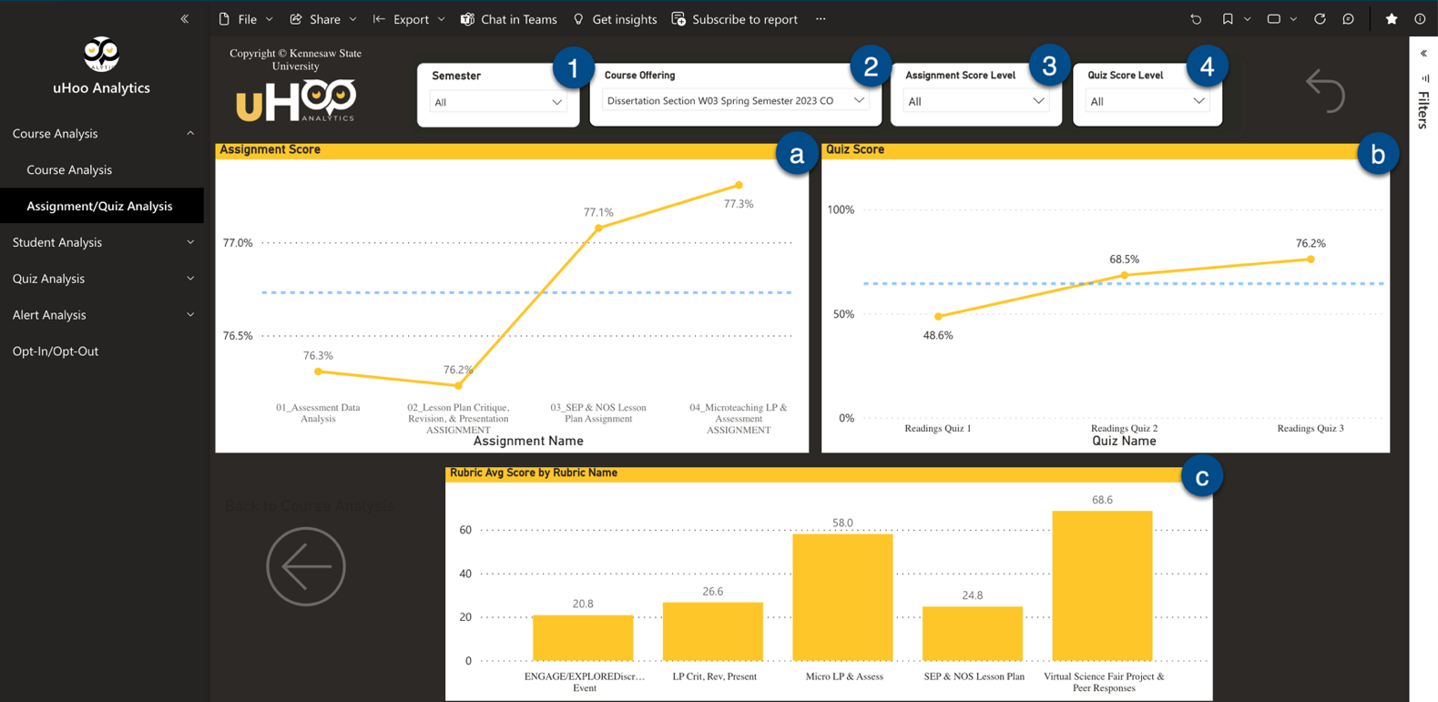
Figure 6 - Screenshot of the Assignment/Quiz Analysis Dashboard

Student Analysis Dashboard
The Student Analysis Dashboard isolates data for one selected student in the selected course. The visualizations on this dashboard are like those on the Course Analysis Dashboard. If a single student is not selected, class data will be displayed.

Filters
- Semester – Click inside this box and select a semester.
- Course Offering - Click inside this box and select a specific course.
- Student Name – Click to select a specific student.

Visualizations
  - Grade Book Item – Compares class average data and data for a selected student on assignments and quizzes. DrillThru is available for this data.
  - Average Rubric Score – This area under construction.
  - Student Attendance by session. (Will appear blank if attendance is not recorded in D2L.)
  - Submodule and Topic Visits – Displays counts for Submodule and Topic level access by student(s).
  - Student Attendance by percent – Displays percentage of classes attended and classes absent.
  - Assignment Alerts – Displays students who have scored a 60% or below on an assignment.
  - Quiz Alerts - Displays students who have scored a 60% or below on an assignment or quiz.
Note: Clicking the email icon will open Outlook and autofill the student’s email.
The Student Analysis Dashboard
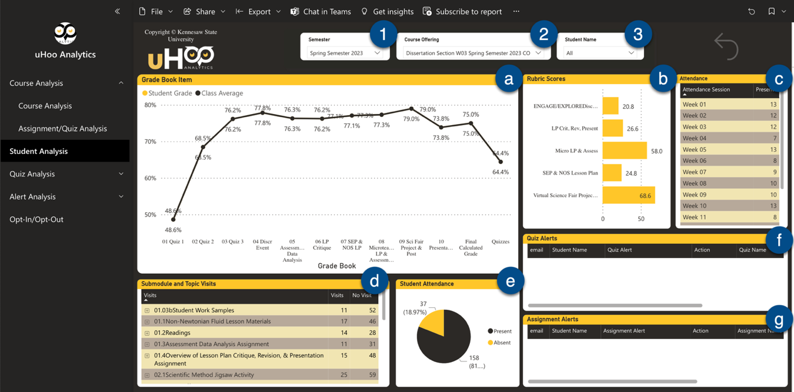
Figure 7 - Screenshot of the Student Analysis Dashboard

IMPORTANT NOTE: To display data chronologically on the dashboards, assignments, quizzes, and modules in D2L must be numbered:
- Assignments: 01 Assignment Name, 02 Assignment Name, 03 Assignment Name, etc.
- Modules: Module 01, Module 02, Module 03, etc.
- Quizzes: Quiz 01 Name, Quiz 02 Name, Quiz 03 Name, etc. -or- Quiz 1, Quiz 2, Quiz 3, etc.

To use the assignment score feature most effectively, grades for the assignments must be entered in the D2L gradebook. Number your assignments/quizzes consistently.

If the data in the visualizations is not displaying correctly, click the RESET arrow at the top right of the page.

Quiz Analysis Dashboard
The data on Quiz Question Analysis Dashboard can be manipulated to identify the questions on quizzes with which students struggled.

Filters
- Semester – Click inside this box and select a semester.
- Course Offering - Click inside this box and select a specific course.
- Quiz – Click inside this box and select a specific quiz.
- Student Name – Click to select a specific student.
- Quiz Grade Level – Click inside this box and select a grade value to view, e.g., all scores below 60.

Visualizations
- % Correct Forced Response Question – Displays percent correct on forced response questions for a selected quiz. Clicking on the bars in this graph will alter other visualizations.
- Quiz Average (Student) - Displays the grade for the student selected in the Student Name dropdown menu on the quiz selected in the Quiz dropdown menu. (Shows the average for all students on all quizzes if a specific quiz or student is not selected.)
- Class Quiz Average - Displays the class average for a quiz selected in the Quiz dropdown menu or for all quizzes in the course if none is selected.
- Incorrect Answers by Student – Shows which students answered the selected question correctly. Clicking on the bars in this graph will alter other visualizations.
- Quiz Score – Displays percent difference between class average quiz score and the selected students quiz score.
- Alert: More than 50% of Students Struggled Answering – Lists quiz questions that were answered incorrectly by at least 50% of the class population. Clicking on the bars in this graph will alter other visualizations.
- Answers to Partial Credit Questions– Displays the percent correct for long and short answer questions on the selected quiz. Clicking the bars in this graph will alter other visualizations.

The Quiz Analysis Dashboard
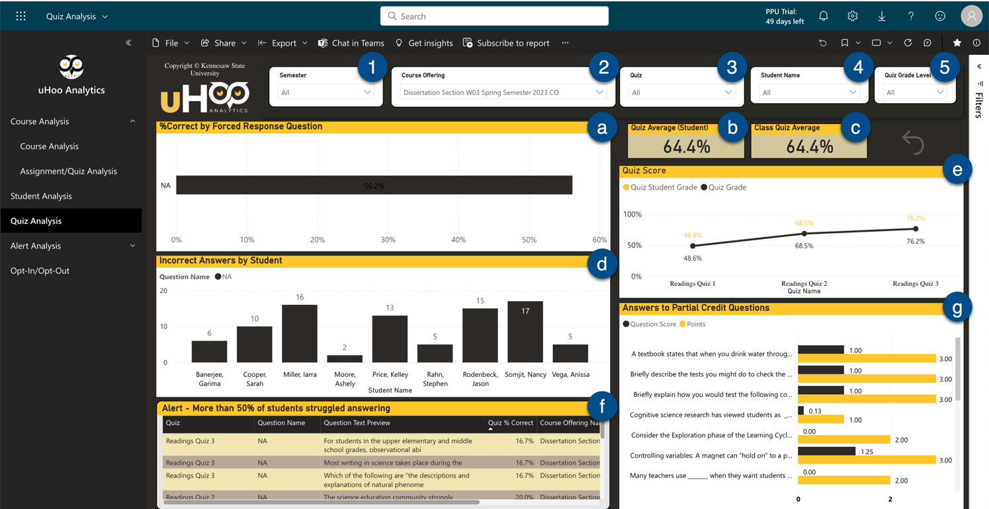
Figure 8 - Screenshot of the Quiz Analysis Dashboard

This dashboard is very interactive. Once a specific quiz is selected, clicking on a question in the % Correct by Question bar graph will cause the Incorrect Answer Count by Student bar graph to show which students answered the question correctly. If applicable, the alert for the question will also be displayed in the Quiz Question Alerts table.
Additionally, selecting a specific student and quiz will show which questions that student answered correctly on the quiz, and if applicable, the alert for the question will also be displayed in the Quiz Question Alerts table.
Finally, selecting a question in the Quiz Question Alerts table will display which students answered the question correctly in the Incorrect Answer Count by Student bar graph.

Alert Analysis Dashboard
The Alert Analysis Dashboard displays alert counts for assignments and quizzes, and for students who have not logged in for seven days or more by the course selected.

Filters
- Semester – Click inside this box and select a semester.
- Course Offering - Click inside this box and select a specific course.
- Assignment Alert Date – Click inside this box and select the week(s) for which you would like to display assignment alerts.
- Quiz Alert Date – Click inside this box and select the week(s) for which you would like to display quiz alerts.
- Quiz – Click inside this box to select a specific quiz.
- Assignment – Click inside this box to select a specific assignment.

Visualizations
- Assignment Average Grade – Displays average for Assignment Grade(s).
- Quiz Average Grade – Displays average for Quiz Grade(s).
- Assignment Alerts – Displays the number of alerts for each assignment. Hover over a section of the donut to see the name of the assignment. Right click on the pop-up to DrillThru to open a table of students with alerts and an option to email them.
- Quiz Alerts – Same as Assignment Alert Count but for quiz alerts.
- No Login Notification- Displays a bar graph of students who have not logged in for at least seven days in descending order. Hover over the bar to see the date of last login.
- User Last Login - Displays the last login date for those listed in the No Login Notification graph.

The Alert Analysis Dashboard
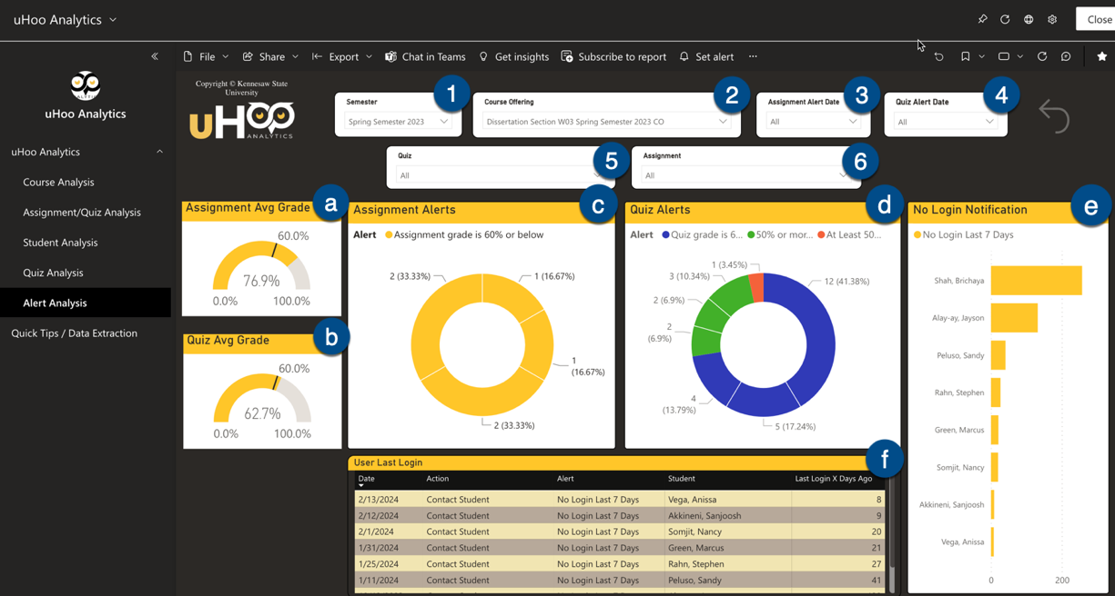
Figure 9 - Screenshot of the Alert Analysis Dashboard

Best Practices in D2L for Instructors

Follow these best practices to enhance uHoo’s data displays visualizations and facilitate analysis.

Assignments
- Remove duplicate assignments – keep only assignments that are being used in the current course.
- Attach all assignments to a grade item in the gradebook.
- Number all assignments so that they appear chronologically in uHoo visualizations. (01Assignment Name, 02Assignment Name, 03Assignment Name)

Quizzes
- Remove duplicate quizzes – keep only quizzes that are being used in the current course.
- Attach all quizzes to a grade item in the gradebook.
- Number all quizzes so that they appear chronologically in uHoo visualizations. (01Quiz Name, 02Quiz Name, 03Quiz Name, etc. -or- Quiz 1, Quiz 2, Quiz 3, etc.)
- Number each quiz question (01, 02, etc.) to easily identify them in the Quiz Question Analysis dashboard.

To show chronological progress for the class in the Course Analysis dashboard, on the Grade Book Item, assignments and quizzes must be numbered sequentially in the order students completed them. For example, if the class had two assignments, then a quiz, then two more assignments, and another quiz, for the trends to be represented in the line graph, the assignments and quizzes should be numbered as follows (with or without spaces between the number and the text):
01 Assignment
02 Assignment
03 Quiz
04 Assignment
05 Assignment
06 Assignment
07 Quiz

Content
- Keep only content being used in current course.
- Number modules and submodules so that they appear chronologically in uHoo visualizations (with or without spaces between the number and the text.
Module 01
01.1Name of submodule
01.2 Name of submodule
Module 02
02.1Name of submodule
02.2 Name of submodule
Module 03
03.1Name of submodule
03.2 Name of submodule
etc.
- Name the modules/topics thoughtfully so that they are clear in the visualizations.

Grades
- Remove duplicate grade items – keep only grade items being used in the current course.
- Use the standardized grading theme: A = 90-100%, B = 80-89%, C = 70-79%, D = 60-69%.
- Attach all grade items to a quiz or assignment. Number the grade items so that it matches the numbers for the assignments and quizzes. For example, the grade book item for 01Assignment should be called “01Assignment.”
- Do not configure the gradebook in D2L to set ungraded items as “0.”
- Note that the Final Calculated Grade data will be pulled from the D2L grade book to display on the Course Analysis dashboard as a Grade Book Item. Because it is not numbered, it will likely appear as the last data point on the line graph. If you have average grades for a category of assignment or quiz grades, it will also appear on the Course Analysis dashboard as a Grade Book Item. For example, if the D2L grade book is averaging all the quiz grades and displaying the average in a column of the gradebook, that data will display in the visualization as a final data point.

Attendance
- Use the attendance tool with the system scheme in D2L for recording student attendance.
- Use American format for dates (MMDDYYYY).

Need Help?
Send email to uHoo@kennesaw.edu or submit a One-on-One Assistance Request and select uHoo.

Tips for Responding to Dashboard Alerts
- Be wholistic in your approach. Review a student’s data to understand the alert and its context before emailing them. The dashboard may provide additional clues and context as to what is going on with the student.
- Be selective with your communication. One well-timed email to address a trend in a student’s progress may be more effective than several quick messages addressing each pain point.
- Be timely with your feedback. Letting students know that you are aware and supportive earlier may help to improve their ultimate success in the course.
- Be positive in your communication. Approach your students with an assets-based approach rather than a deficit approach (all learners have assets during the learning process). Click here for examples of asset-based feedback.
- Be a Team. Frame the situation as a problem you are both working to solve together. (e.g., “It seems like you scored much lower on this quiz than on the previous three quizzes. Was there a concept that I can help clarify?”)
- Be constructive. Word your student emails using specific academic encouragement vs. praise (e.g., You might say, “I really liked the way that you demonstrated your understanding of (the concept). I look forward to reading how you apply this understanding to new situations in the future,” rather than, "Good job.”
- Be data focused. Let students know you are responding to learning analytics data to help support them!

Documenting your Impact on Student Success
How do you measure student success in your classroom? What does it look like? And how does your teaching make the greatest impact?
We all strive to be effective teachers, and uHoo Analytics can help. Like researchers, if we collect and analyze data and use it to form conclusions that impact our instructional decisions, we are applying our research skills to become more effective teachers. In effect, we are learning scientists practicing learning analytics. Learning analytics is...
Measurement, collection, analysis, and reporting of data about learners and their contexts for the purpose of understanding and optimizing learning and the environment and which it occurs (What is Learning Analytics?, Society for Learning Analytics Research).
Becoming a learning scientist by using the research skills you already have can have a positive impact on P&T and ARD decisions. Put those skills and uHoo Analytics to work! Amazing teachers think like researchers.
Consider these means to document evidence addressing possible Student Success Goals:
- Trends: Consider the data offered by uHoo. Data in the Learning Analytics Dashboard can make it easier for you to identify trends associated with your teaching. Do you notice that students performed better after you hosted a review session?
- Issues: When analyzing specific assignments or topics, note if a particular quiz question or rubric criterion was missed by a significant number of your students. Then, consider narrating the steps you took to resolve the issue or address it in future assignments.
- Interventions: Note your interactions with students and their impact. The dashboard will help you track when you contact individual students regarding their progress in the course. Can you identify situations where your timely contact helped a student catch up or perform better
- Artifacts: Consider ways that you can capture your students’ progress as well as your support during the course using the visualizations provided by the Learning Analytics data (e. g. Screenshots of the Course Analysis and Student Analysis Dashboards). These artifacts document the impact of your teaching in a visual, impactful way!

Also, consider that using uHoo to collect data about supporting student success will free up some time for you to attend to other university commitments and obligations!

Learning Analytics for SoTL Research
If you are interested in exploring how learning analytics may be used to support the Scholarship of Teaching and Learning (SoTL)—i.e., research on teaching and learning done by instructors in all disciplines—please contact Dr. Hillary Steiner, Associate Director for SoTL at the Center for Excellence in Teaching and Learning (CETL), for an individual consultation, workshop, or micro credentialling opportunity. Dr. Steiner is available to help you with all stages of the SoTL research process.

Ethics and Learning Analytics
The use of data and analytics to understand and improve learning processes comes with several ethical considerations. Here are some key considerations in learning analytics:

1. Privacy
Learning analytics often involves collecting and analyzing substantial amounts of data, including personal and sensitive information about learners. It is crucial to protect the privacy of learners and ensure that their data is collected, stored, and used in a secure and confidential manner. Please DO NOT forward the Monday Measures emails or share information in your dashboard with anyone who is not authorized to view it.

2. Data Accuracy and Interpretation
Learning analytics relies on accurate and reliable data to help instructors generate insights. Please be sure the data you enter is accurate and valid; otherwise, the insights generated may not be correct or helpful. Additionally, it is crucial to interpret the analytics results appropriately and avoid making unfair or discriminatory assumptions about learners based on the data.

3. Equity and Fairness
When analyzing data, it is important to consider potential biases -that could disproportionately affect certain groups of learners, such as gender, race, or socioeconomic background. Does the data indicate that a marginalized group of students underperformed others in the class? Efforts should be made to identify and address biases in activities and/or assessments to ensure that they support equal opportunities and fair outcomes for all learners.

4. Ethical Use of Results
The insights and results generated through learning analytics should be used ethically and responsibly. They should be employed to improve teaching and learning practices, enhance learner experiences, and support decision-making processes. Learning analytics should not be used to harm or discriminate against learners, undermine their autonomy, or exploit their personal information for commercial purposes.

5. Professional Responsibility
Learning scientists have a professional responsibility to maintain high ethical standards. They should stay informed about the latest ethical guidelines and best practices in learning analytics, seek ongoing professional development, and actively engage in ethical discussions and decision-making related to data collection, analysis, and use. Instructors should not share data with those not authorized to access it.

These ethical considerations aim to ensure that learning analytics is conducted in a manner that respects the rights, well-being, and dignity of learners while maximizing the benefits and minimizing the risks associated with data-driven approaches in education.

Additional Resources

- The Ethics of Learning Analytics: A Framework for Understanding and Addressing Ethical Issues in the Use of Learning Analytics by Paul A. Jones, David Wiley, and Mark A. Hurst (2015)
- Learning Analytics: Ethical Issues and Good Practices by Lars Arge (2017)
- The Ethics of Learning Analytics: A Literature Review by Ivailo Iliev, Georgios Papamitsioudis, and Yannis Dimitriadis (2016)
- Ethical Considerations for the Use of Learning Analytics in Higher Education by John M. Carroll, David Wiley, and Paul A. Jones (2014)
- The Ethics of Learning Analytics: A Guide for Practitioners by the Learning Analytics Community (2017)

These sources provide an overview of the ethical issues involved in learning analytics. They discuss the potential benefits and risks of learning analytics, and they offer recommendations for how to use learning analytics in an ethical and responsible way.

