FAQs for Copilot and Generative AI
Contents
Copilot FAQs 2
What is Copilot? 2
What are the differences between Copilot and ChatGPT? 2
How can I access Copilot? 2
Is my data secure with Copilot? 2
How reliable is Copilot-generated content? 3
Can I upload documents to Copilot? 3
Can I upload images to Copilot? 4
What is a conversation style? Does Copilot have character limits? 4
Is Copilot accessible? 5
How can I generate text using Copilot? 5
How can I generate images using Copilot? 6
KSU-Specific FAQ Questions 6
What can I use at KSU for image generation? 6
Can I use ChatGPT at KSU? 6
What is KSU’s institutional policy related to AI? 6
Is there training available for Generative AI at KSU? 6
Who can I contact if I have a Gen AI/Copilot question? 6
General Generative AI FAQ 7
What is Generative AI? 7
What is an LLM? 7
What is deep learning? 7
What are neural networks? 7
What is ChatGPT? 7
What is DALL-E? 7
What is prompt engineering? 7
What are some best practices for writing effective prompts? 8
References 8

Copilot FAQs

What is Copilot?
Microsoft Copilot is a cutting-edge AI tool that generates original text or images in response to user instructions, known as prompts. Copilot integrates advanced AI models like GPT-4 and DALL-E 3 (with limitations) for personalized and efficient interactions, assisting with tasks such as drafting emails, creating images, and generating draft teaching materials.

What are the differences between Copilot and ChatGPT?
Copilot is built using the underlying technology of ChatGPT4; however, there are some significant differences. One major difference is that Copilot protects personal and company data when accessed via a KSU account, while ChatGPT does not. The most advanced version of ChatGPT also requires a subscription, while Copilot is included as part of KSU’s Microsoft license.

How can I access Copilot?
Refer to ‘How to access Microsoft Copilot’ for step-by-step log in instructions. You will need to use your KSU NetID and password to log into Copilot. Copilot work mode is designed for workflow while web mode is used for information gathering. You can also access Copilot on mobile devices. Refer to the DLI-created Microsoft Copilot Video for additional instructions and explanation.

Is my data secure with Copilot?
When you sign-into Copilot with your Kennesaw credentials, personal and company data are protected using Copilot. Look for the “protected” sign at the top right-hand corner of the page. Commercial data protection means both user and organizational data are protected: prompts and responses are not saved, and chat data is not used to train the underlying large language models.

Figure 1: Copilot 'Protected' Icon
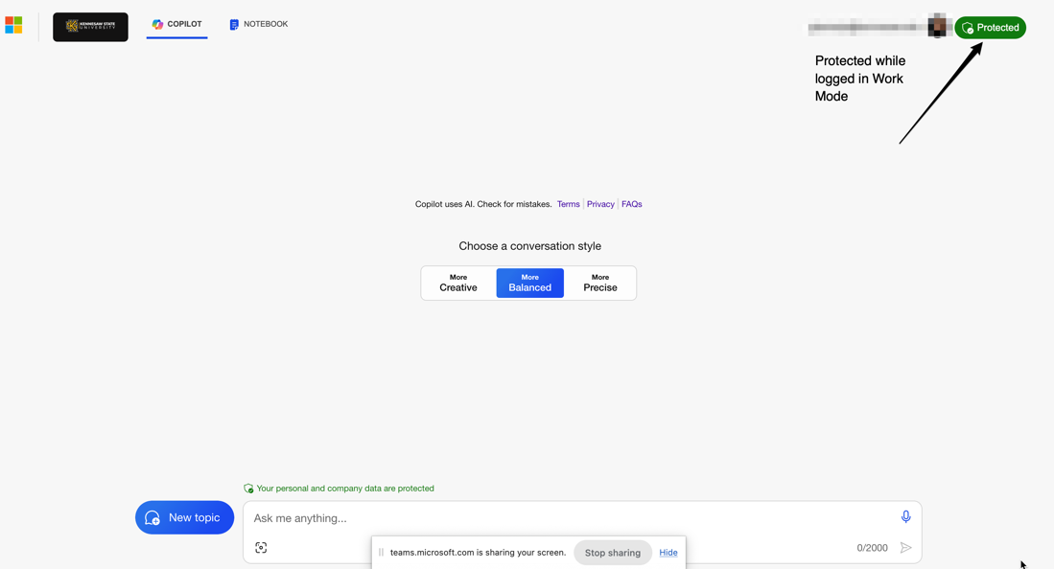

Generated content and prompts are not saved if logged in using your KSU NetID (Work mode). You will know your information is protected by the “Protected” button. However, if you use Copilot using Bing search, then your data is not protected.

How reliable is Copilot-generated content?
Like all generative AI models, users should critically evaluate any Copilot-generated content for accuracy, relevance, and bias. The reliability of Copilot generated content depends on the quality of prompts and the data the model has been trained on. Remember, all generative AI models are prone to some level of hallucination. Hallucination is where chatbots generate incorrect, misleading, or weird answers. The longer your conversation threads are, the more likely this is to occur. This is one reason Copilot has a limit of 30 responses before a new conversation must be initiated.

Can I upload documents to Copilot?
You can upload images or documents directly to Copilot by selecting the paperclip icon in the prompt window. Remember to give Copilot clear instructions for what to do with the information. This is a useful technique for generating alternative text for images or infographics.

For documents longer than one page, Copilot generally does a much better job analyzing the contents when the document is opened as a PDF or webpage in the Edge browser, rather than working directly in the chat window.

Figure 2: Using Copilot in Edge
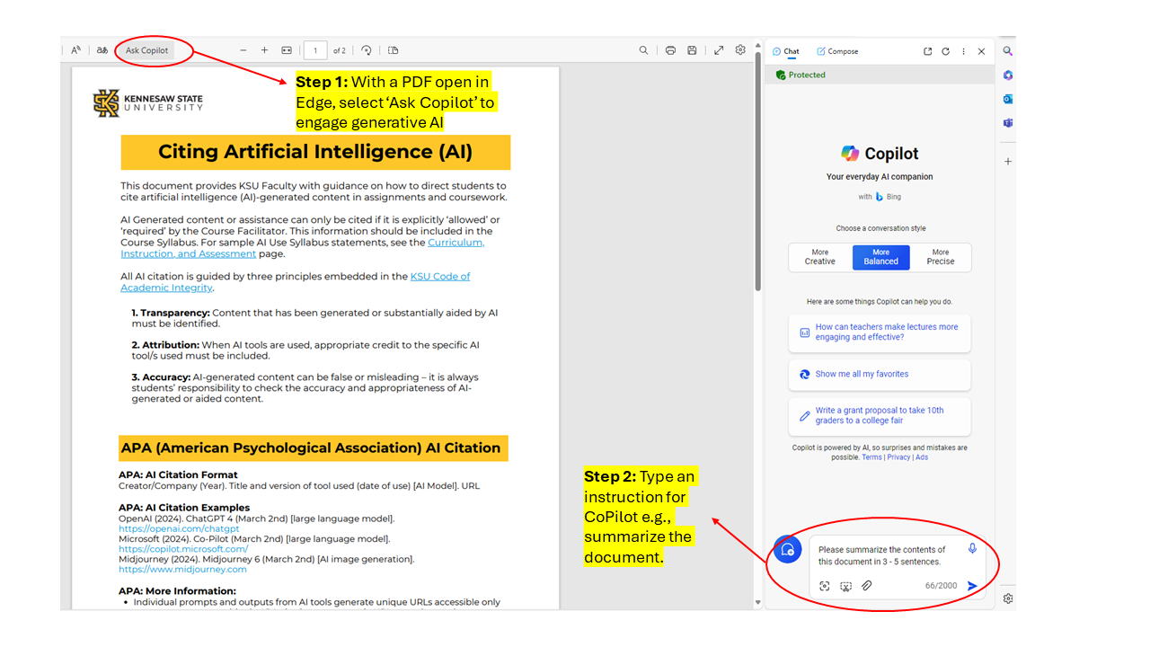

Can I upload images to Copilot?
Yes, you can upload images as well as take a photo in Copilot using the “image” icon on the left side of the prompt window. Copilot will also generate alt text for the image it generates.

Figure 3: Copilot Image Upload Icon
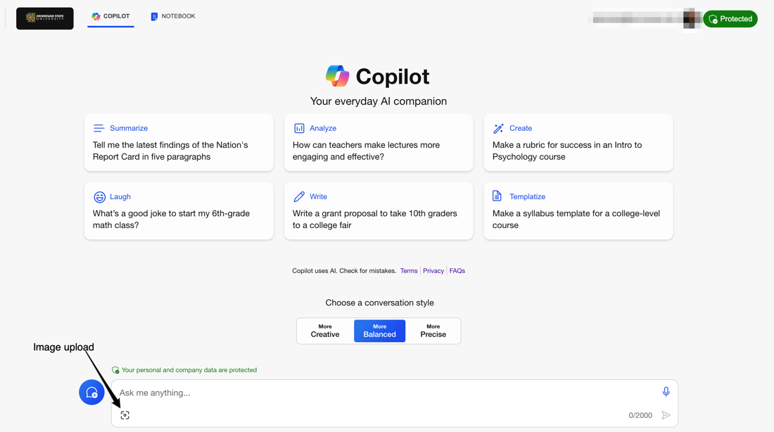
With Copilot you can generate 30 images per day. You also have access to 100 image enhancements, known as ‘boosts’. An ‘image boost’ involves enhancing a generated image by adjusting various parameters, such as color balance, contrast, sharpness, or artistic effects.

What is a conversation style? Does Copilot have character limits?
There are 3 conversation styles available in Copilot:
- Creative: 4000 characters input, generates longer, imaginative answers.
- Balanced: 2000 characters input, aims to strike a balance between creativity and precision.
- Precise: 4000 characters input, delivers concise answers that prioritize accuracy and relevancy.

Each conversation style is limited to 30 responses due to the increasing risk of AI hallucinations.

Figure 4: Copilot Conversation Styles
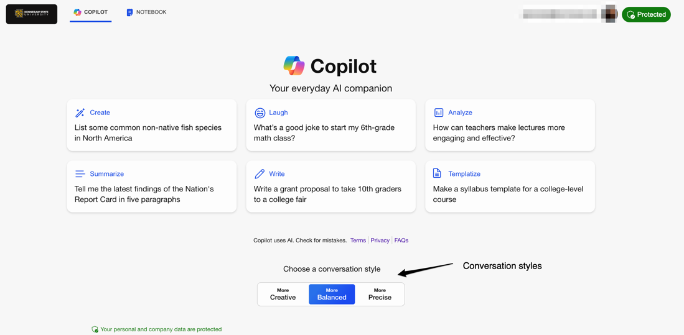
Copilot also has a “Notebook” option that you can use for up to 18000-character input. This is a more enhanced version of Copilot and can be used for more complex prompts. For example, the Notebook section can help you analyze research passages if you copy the passage in the prompt.

Figure 5: Copilot Notebook Feature
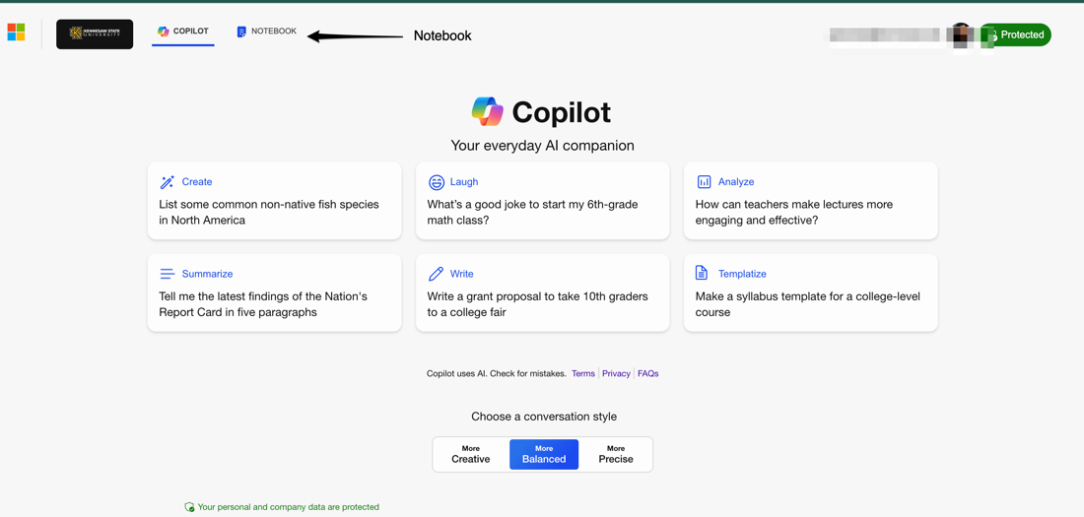

Is Copilot accessible?
When it comes to web accessibility standards, Copilot adheres to best practices to ensure that its interface is usable and inclusive for all users, including those with disabilities.

Here are some key aspects:
- Semantic HTML: Copilot generates HTML code that follows semantic structure. This means using appropriate HTML elements such as a heading structure to convey meaning and hierarchy.
- Alt Text for Images: When Copilot processes images, it generates alt text for them. Alt text provides a textual description of the image content, which is essential for users who cannot view images.
- Screen Reader Compatibility: Copilot generates content that is compatible with screen readers. It avoids using purely visual cues (like color alone) to convey information.
- Voice-enabled questions and responses: The microphone icon can be used to communicate prompts verbally, and the speaker icon vocalizes responses.

How can I generate text using Copilot?
To generate text using prompts, log into Copilot. Use the prompt window and effective prompt writing techniques to write instructions for the text you want the AI to generate.

For example, if you want to generate some module-level objectives for a KSU course you are working on, you might enter the prompt:
You are an expert learning designer in [x discipline] at a top US university. Use the course outcomes pasted below to develop a series of module learning objectives for [course name and level]. There will be a total of [x number] of modules, and each module represents [x weeks] of study. For each module, generate between 3 and 5 learning objectives. Each learning objective must start with a specific and measurable action verb and must be sequenced to progress from lower to higher order thinking skills on Bloom’s taxonomy. [Paste course outcomes here]

Quick Exercise: Try the above prompt and see the results for yourself. Change/Refine instructions based on your needs.

How can I generate images using Copilot?
To generate images, log into Copilot. Use the prompt window and effective prompt writing techniques to write instructions for the image you want the AI to generate.

For example, if you want to generate an original cover image for your course, you might enter the prompt:

You are an expert graphic designer and Computer Science Professor. Create a rectangular banner image for a first year 'Introduction to AI' course. The image should be in an abstract style and highlight the vast potential of human collaboration with AI. Include at least three cartoon owls in the image, styled on the design of the Kennesaw State University mascot, Scrappy.

Quick Exercise: Try the above prompt and see the results for yourself. Change/Refine instructions based on your needs.

KSU-Specific FAQ Questions

What can I use at KSU for image generation?
The approved and supported tools for image generation at KSU are Copilot and Adobe Firefly. When using Copilot, remember the image generation limits as it can start hallucinating and produce results that may not be desirable.

Can I use ChatGPT at KSU?
KSU has a Microsoft license, so all students and staff have access to the paid version of Copilot (work). While built using the same underlying technology, ChatGPT is a different product, and the most powerful version (currently GPT4) requires a paid subscription.

What is KSU’s institutional policy related to AI?
Like many institutions, KSU does not yet have a defined institution-wide AI use policy. However, as part of KSU’s license with Microsoft, Copilot is available to all staff and students. Users must sign-in to Copilot with their KSU NetID and password so that any information entered in Copilot is protected and FERPA-compliant. For more information regarding the use of Copilot in teaching and learning, read the KSU AI Use Syllabus Statements, Considerations, and Citation Guidance.

Is there training available for Generative AI at KSU?
Digital Learning Innovations (DLI) has produced a set of resources designed to support KSU faculty interested in exploring AI for teaching, learning, and productivity. Explore the DLI AI page to learn more about generative AI and how it can enhance teaching and learning, as well as important ethical considerations.

Who can I contact if I have a Gen AI/Copilot question?
For advice around how to implement AI safely and ethically into KSU courses, schedule a one-on-one consultation with an instructional designer at Digital Learning Innovations. For technical questions related to access to KSU supported AI tools, contact University Information Technology Services (UITS).

General Generative AI FAQ

What is Generative AI?
Generative AI refers to a type of artificial intelligence system that can generate content, such as text, image, audio, and video in an automated way. For more information, view the infographic and video.

What is an LLM?
A large language model (LLM) is a type of artificial intelligence (AI) program that can recognize and generate text, among other tasks. LLMs are trained on huge sets of data — hence the name "large." LLMs are built on machine learning: specifically, a type of neural network called a transformer model.

In simpler terms, an LLM is a computer program that has been fed enough examples to be able to recognize and interpret human language or other types of complex data. Many LLMs are trained on data that has been gathered from the Internet — thousands or millions of gigabytes' worth of text. But the quality of the samples impacts how well LLMs will learn natural language, so an LLM's programmers may use a more curated data set.

What is deep learning?
Deep learning is a type of machine learning that can recognize complex patterns and make associations in a similar way to humans. Its abilities can range from identifying items in a photo or recognizing a voice to driving a car or creating an illustration. A deep learning model is a computer program that can exhibit intelligence, thanks to its complex and sophisticated approach to processing data.

What are neural networks?
Neural networks are computational models inspired by the human brain's architecture, designed to recognize patterns, and make decisions through layers of interconnected nodes or "neurons." These networks learn to perform tasks by considering examples, generally without being programmed with task-specific rules. They are a foundational element of artificial intelligence and machine learning.

What is ChatGPT?
ChatGPT (Chat Generative Pre-Trained Transformer) is a chatbot developed by OpenAI and launched on November 30, 2022. Based on a large language model, it enables users to refine and steer a conversation towards a desired length, format, style, level of detail, and language. Updated versions of ChatGPT such as ChatGPT 4 are also able to generate images and interpret uploaded images and files.

What is DALL-E?
Dall-E3 is AI model that uses a prompt or prompts to generate images developed by OpenAI. Both Copilot and ChatGPT 4 leverage Dall-E3 for image generation.

What is prompt engineering?
The information, sentences, or questions that you enter the prompt window of a Generative AI tool is called a prompt. The quality of prompts has a considerable influence on the quality of outputs you receive.
Prompt engineering is the process of refining prompts that you input into a generative artificial intelligence (AI) model to create text or images. Anyone can do this using natural language in generators like CoPilot, ChatGPT or DALL-E. You do not have to be a coder or programmer to use prompts.

What are some best practices for writing effective prompts?
Some best practices for writing prompts include:
- Adding additional guidance in terms of role, tone, and context
- Making sure the prompt is specific
- Making sure the information added is not too much as that can confuse the model
- Making the user intent and purpose clear for the model.

References

- Generative AI Infographic | Rise 360 (articulate.com)
- Generative AI Microlearning - KSU Media Space (kennesaw.edu)
Cloud Flare Learning AI Website
- Generative AI - Digital Learning Innovations (kennesaw.edu)

