CCSE Faculty/Staff Searches

# Training

Academic Affairs Hiring Training <https://www.kennesaw.edu/faculty-affairs/hiring-policies/index.php>

Tips for Conducting Interviews <https://www.kennesaw.edu/human-resources/careers/talent-acquisition/interviewing.php>

Inclusive Hiring courses

Workshop on Preventing Discrimination and Fostering Equity on Sept. 9th <https://events.teams.microsoft.com/event/75a24f3f-40dc-4152-b0d0-8795aba30803@45f26ee5-f134-439e-bc93-e6c7e33d61c2>

[Counteracting Implicit Bias in the Hiring Process](https://nam04.safelinks.protection.outlook.com/?url=https%3A%2F%2Fshare.percipio.com%2Fcd%2F-2UKWB-_p&data=05%7C02%7Cspeltsve%40kennesaw.edu%7C30875490ccd74da4f07208dcc8699f75%7C45f26ee5f134439ebc93e6c7e33d61c2%7C1%7C0%7C638605603355101342%7CUnknown%7CTWFpbGZsb3d8eyJWIjoiMC4wLjAwMDAiLCJQIjoiV2luMzIiLCJBTiI6Ik1haWwiLCJXVCI6Mn0%3D%7C0%7C%7C%7C&sdata=MdsTabY4EJZrZViJv8R4G8kGIlTaLR%2FIezXqQGcTC%2Fs%3D&reserved=0) (This is an AI powered simulation tool for people doing hiring)

Search Committee Member Access in oneUSG Connect Careers <https://www.kennesaw.edu/faculty-affairs/docs/search-committee-member-access-oneusg-connect-careers.pdf>

# Compliance

Guidelines for Conducting Faculty Searches at Kennesaw State University: <https://www.kennesaw.edu/faculty-affairs/hiring-policies/faculty-guidelines-2023.pdf>

Guidelines for Conducting Staff Searches at Kennesaw State University <https://intweb.kennesaw.edu/hr/public/staff-search-guidelines.pdf>

Central Repository Instructions <https://www.kennesaw.edu/human-resources/careers/talent-acquisition/staff-hiring-process.php>

It is recommended to use the template below as you progress through the hiring process. This template includes all the required elements that must be submitted at the end, regardless of whether the position is filled, or the search is unsuccessful. The search committee chair should maintain ownership of the document. Remember to back up this document regularly. Once completed, the document and the signed confidentiality agreements should be submitted to the hiring manager.

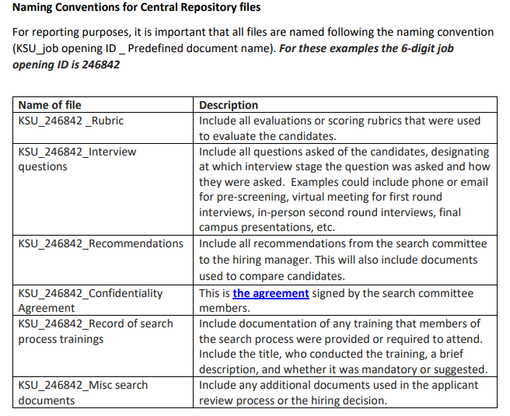

Below is a link to a new reference guide for the faculty searches central repository. This document ties the Faculty Search Guidelines required documents to the central repository documents and naming scheme. Hopefully, this will help make it easier to navigate this task <https://www.kennesaw.edu/faculty-affairs/hiring-policies/docs/central-repository-reference-guide-v2.pdf>

The OneUSG central repository instructions are still a separate document, see link below.

<https://www.kennesaw.edu/human-resources/careers/talent-acquisition/staff-hiring-process.php>

# Template

## Initial meeting

Committee members: (min 5 for faculty searches)

* Chair:
* Cm1
* Cm2
* Cm3
* Cm4

Charge meeting with the hiring manager: date

Sign confidentiality agreements <https://intweb.kennesaw.edu/hr/public/confidentiality-agreement-search.pdf>: date

Assigned required and optional training

Meeting date

## Timeline

1. Work on the job description: dates
2. Posting: anticipated date
3. Application deadline/start screening: date
4. Send the pros and cons of the phone/virtual interview candidates to the hiring manager: dates (recommended within 1-2 weeks from the application deadline)
5. Phone/virtual interviews: dates (it is recommended to block times for phone/virtual interviews for search committee members as early as possible)
6. Check references if a candidate agreed to on-campus interviews: dates
7. Send the pros and cons of the candidates for an on-campus interview to the hiring manager
8. On-campus interviews: dates (It is recommended to schedule time blocks for on-campus interviews as early as possible for search committee members, the hiring manager, and, if applicable, the Dean and the entire academic unit). See Appendix C for the suggested format of the interview.
9. If hiring for a position with tenure or a rank higher than Lecturer/Assistant Professor, consult the department or school P&T committee to obtain a letter of recommendation for the finalist’s tenure and rank.
10. Offer: target date

## Posting

Date the job posting is active on oneUSG: date

Copy of the job responsibilities:

Position advertisements:

## Rubric

Create a rubric based on job descriptions and key responsibilities:

## Questions

See sample questions in Appendices A and B

### Phone Interview Questions

1. x

### Reference Check Questions

1. x

### On-Campus Interview Questions

1. x

### Survey Questions (if applicable)

1. x

## Applicants

### Applicants not chosen for a virtual interview

OneUSG categories for rejection

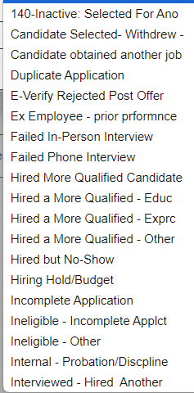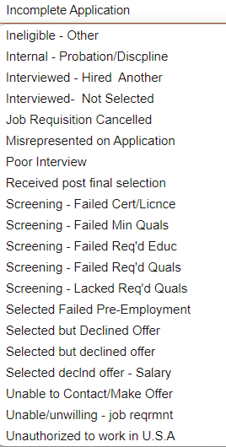

#### Candidate 1 name

The reasons why the candidate was not selected

#### Candidate 2 name

The reasons why the candidate was not selected

### Applicants chosen for a phone/virtual interview

#### Applicants not chosen for on-campus interview

Candidate 1 name

Virtual interview date

Pros of the candidate (notes of the committee members)

Cons of the candidate (notes of the committee members)

Candidate 2 name

Virtual interview date

Pros of the candidate (notes of the committee members)

Cons of the candidate (notes of the committee members)

#### Applicants chosen for on-campus interview

Candidate 1 name

Virtual interview date

Pros of the candidate (notes of the committee members)

Cons of the candidate (notes of the committee members)

Candidate 2 name

Virtual interview date

Pros of the candidate (notes of the committee members)

Cons of the candidate (notes of the committee members)

### Finalists List to the Hiring Manager

Candidate 1 name

On-campus interview date

Pros of the candidate (notes of the committee members)

Cons of the candidate (notes of the committee members)

Reference check: reference name, date, the person conducting the reference check, and notes from the reference check call.

Itinerary of the campus visit

Candidate 2 name

On-campus interview date

Pros of the candidate (notes of the committee members)

Cons of the candidate (notes of the committee members)

Reference check: reference name, date, the person conducting the reference check, and notes from the reference check call.

Itinerary of the campus visit

Candidate 3 name

On-campus interview date

Pros of the candidate (notes of the committee members)

Cons of the candidate (notes of the committee members)

Reference check: reference name, date, the person conducting the reference check, and notes from the reference check call.

Itinerary of the campus visit

# Appendix A Sample Questions for Staff

Phone interview questions (15 min)

1. Brief intro to KSU and CCSE. Thank you for your application; we read your resume and have additional questions.
2. Describe how your work experience relates to this job.
3. Why do you want to work for KSU and the College of Computing specifically?
4. What is your experience working with Microsoft Office/Banner/Works/etc?
5. How do you approach learning new technologies or new software?
6. Tell us about your experiences working on a team.
7. Do you have any questions for us?

On-campus interview questions (30 min)

1. Longer version of CCSE and KSU overview. Thank you for answering the phone interview questions, we have some additional questions.
2. Name two professional achievements you are most proud of and how they align with the goals you hope to achieve at CCSE.
3. What do you do when you have too much work for a given period of time?
4. What would be your ideal growth path in your job? Where do you see yourself in one, three, and five years from now?
5. What things did you like best about your previous job? What did you like the least about it?
6. When you have experienced frustrations with your job, what did you do about it?

**Scenario questions:**

1. A student who is trying to call in for an advisor cannot get someone on the phone and does not want to e-mail, so they call you. What do you do?
2. You keep receiving emails and phone calls from a parent you have previously directed to the registrar's office about FERPA. How do you handle this parent?
3. There is a faculty member with a strong accent, and you do not understand what they are asking. What do you do?
4. What else should we know about you?
5. Do you have any questions for us?

Reference check questions (10 min)

1. Brief intro to KSU, CCSE and the position. What is your opinion on their potential to enhance the college's operational efficiency?
2. What is your opinion of their potential to work without supervision?
3. How would you describe their performance in comparison with other people in similar positions?
4. How was their progress in your organization? What are their strong points?
5. What are their limitations?
6. How well did they get along with coworkers? Customers?
7. How did they react in the face of an unpopular management decision?
8. Please comment on dependability and potential for advancement.
9. Why are they seeking a change?
10. Is there anything else of significance that we should know?

# Appendix B Sample Questions for Faculty

## Phone/Virtual Interview Questions

1. Brief intro to KSU/CCSE/Academic Unit.
2. Can you briefly introduce yourself and explain why you are interested in this position at KSU, specifically in our department?
3. What are your primary research/teaching interests, and how do you see them evolving over the next few years?
4. Could you share how you organize and prioritize your tasks to balance teaching, research, and service responsibilities?
5. Do you have any questions for us or anything else you’d like to add about your candidacy?

## On-Campus Interview Questions

1. What motivated you to choose KSU and, specifically, our department? If applicable, why are you considering leaving your current position?
2. Can you outline your research plan, including your short-term and long-term goals?
3. How do you envision your research contributing to the growth and development of our department?
4. Which courses are you most interested in teaching? Are there any courses you would prefer not to teach? Please name two courses you would be excited to teach and two you would rather not.
5. In a classroom with students of varying backgrounds and prior knowledge, how do you ensure that your teaching is effective and appreciated by all students?
6. How would you approach teaching a course that you hadn’t anticipated or that falls outside your primary field of expertise?
7. Could you describe how you organize, plan, and prioritize your work, especially in a dynamic academic environment?
8. **(ONLY FOR ABDs):** You haven’t quite finished your degree – what is your expected graduation date?
9. Do you have any questions for us?

## Reference Check Questions

1. How long and in what context have you known the candidate?
2. What is your opinion of his/her potential as a xxx.
3. What are his/her limitations?
4. How well did he/she get along with colleagues?
5. How did he/she react in the face of an unpopular management decision?
6. Please comment on his/her
   * Dependability. 100%
   * Ability to take on responsibility 100%
   * Potential for advancement
7. Is there anything that interfered with his/her work?
8. Why is he/she seeking a change?
9. Is there anything else of significance that we should know?

## Questions for the survey via Qualtrics

1. I have read the candidate's CV Yes/No
2. I have attended the candidate's presentation Yes/No
3. Personality/Disposition Comments:
4. Effective communication Comments:
5. Overall potential to
   1. Be externally funded Comments:
   2. Be recognized as an excellent teacher Comments:
   3. Be engaged in the CCSE/KSU and professional community Comments:
6. Other strength
7. Other weaknesses

# Appendix C Sample Interview Schedules

Staff Interview

* Search Committee 30 min
* Hiring Manager 15 min

Faculty Interviews

* 8:00 am Pick the candidate from the hotel.   
   Breakfast is usually included in the hotel rate
* 8:30 – 8:50 am Meet with Dean J331
* 9:00 – 9:45 am Meet with Search Committee J381
* 9:45am – 10:20am Tour of the Campus
* 10:30 – 11:30am Presentation J101
* 12:00 – 1:00 pm Lunch with the unit leader Stingers
* 1:15 – 1:35pm (if applicable) Meet with AD for Research
* 1:40 pm – 2:00pm (if applicable) Meet with the office manager for travel   
   reimbursement paperwork